Utilizing Group.io Calendar with RSVP function
Contents
Utilizing Group.io Calendar with RSVP function 1
Leaders 1
Attendees 8
Example of Emails 9
Example of Calendar RSVP page 10

Leaders
Go to the Calendar in the appropriate group or subgroup (for purposes of testing go to the Training Subgroup. For actual event posting go to the Main Subgroup)
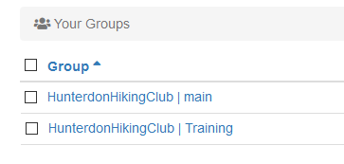
- Click on the date of the event

In the Event form fill in
- Event Name Ex. Baldpate Mountain Hike
- Date and Time It has been suggested that we include the meeting time, so uncheck the All Day box and specify the meeting time under Start. Select a good guess for End time.

Under Event Information, enter
- Location The actual meeting location should not be specified, as we are keeping it hidden at this point. It should be the same as the title with generalized information – ie. Lebanontownship, In Pennsylvania, South Jersey.
- Organizer Name The name of the event leader
- Organizer Email The email of the event leader
- Organizer Phone The phone number of the event leader. Both Cell and Home numbers can be entered, as it is free form.

Example:
Event Information
Location
Baldpate Mountain
Organizer Name
Charlie B
Organizer Email
Charles.behnken@xxxx.com
Organizer Phone
908-391-xxxx (C) 908-735-xxxx (H)

- Description This should be the usual description of the hike including Class and Distance. It can contain lunch information and a brief description of the hike. Format it as you wish (bold, font, etc.)

Do not include meeting point! We are hiding this information.

Important! Include the following verbiage at the bottom of the description:
The meeting point will be sent out to those whose request is accepted under the RSVP rules.
Terms and conditions, including the liability waiver, for HHC activities may be found on Groups.io in the Files section under HHC Forms and Guidelines.
You will be required to sign the liability waiver at the trailhead. If you do not feel comfortable doing that, bring a signed copy with you and give it to the leader.
Do not reply to this email. Only RSVPs will be accepted.

Example:
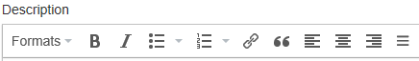
6.0 Miles,
Class 3C

We'll hike the Patriots Path from Lewis Morris Park through the Jockey Hollow National Historical Park and back. Bring lunch/snacks.

The meeting point will be sent out to those whose request is accepted under the RSVP rules.

Terms and conditions, including the liability waiver, for HHC activities may be found here - https://hunterdonhikingclub.groups.io/g/main/files/HHC%20Forms%20and%20Guidelines/For-Leaders-Liability-Waiver-Sign-In-Sheet%20%28COVID-19%20rev%29.pdf

You will be required to sign the liability waiver at the trailhead. If you do not feel comfortable doing that, bring a signed copy with you and give it to the leader.

Do not reply to this email. Only RSVPs will be accepted.

RSVP Section
- Check the Request RSVP box and additional fields will be displayed.
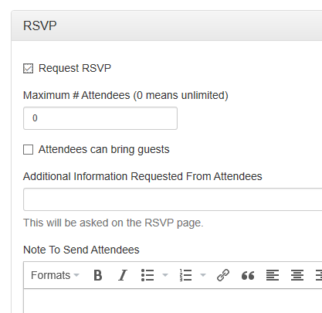
NOTE: once I saw a screen without the Request RSVP and check box. Clicking on the word RSVP brought up the additional fields.
Fill in the fields as follows:
- Maximum # of Attendees. Currently the maximum for hikes should be 10 (20 if there is an overflow hike). Do not select 0/unlimited!
Include yourself and immediately accept the invitation after sending.
Anyone who accepts above the maximum will be put on the waitlist.
- Select Attendees can bring guests. This is to allow a couple with only one Groups.io account to add their spouse. Non-members are not allowed at this time!
- Additional Information Requested From Attendees Leave blank
- Note to Send Attendees This is where we unveil the meeting time and meeting location.
You can also add the event description, class, distance, lunch information or any other information you wish to send to those accepted. Unfortunately, you cannot attach driving directions. Format as you wish.
Example: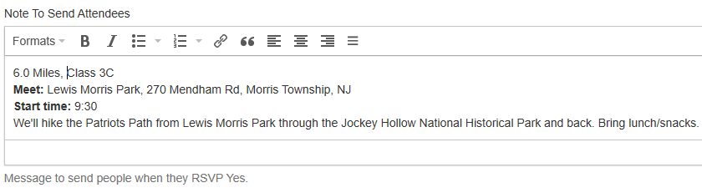

- Do not select the Add Reminders button.
- Review the entry making sure you have the required verbiage.
Once you are satisfied with everything has been specified correctly, click Add Event & Invite Group. This will send an Invite to the subgroup.
If you want to save a draft and not send it, select Add Event. Just remember to send it two weeks before.

When someone accepts the invitation and there are available slots, Groups.io will send a second email to attendee with the information specified in Note to Send Attendees. This is how they will learn the meeting place and location.

Before the event, when all have accepted, click on View Responses to see who is attending.

TIPS:
- You can send an email to the accepted attendees from the View Responses screen by using the options under the Green Email Icon. This could be used to send the driving directions to the group. NOTE: there have been reports that email sent this way ends up in members SPAM or JUNK folder. Groups.io has no idea why.
- You can enter your events in advance by clicking Add Event. After you do that go back to the Calendar, select the event and at the bottom click on Lock Event. This will prevent someone from RSVPing before the Event is sent out. Two weeks before select the event and click on Unlock Event and then click on Edit Event . Scroll to the bottom and select Update & Invite Group (no need to actually make a change).
Anyone attempting to RSVP while the Event is locked will get an error message stating the Event is locked.
- You can change the number of Attendees through Edit Event. If you increase the number, the next people on the Waitlist will be accepted. If you decrease the number there will be no change to the Attendee list, however if someone changes to Will Not Attend, no one will be moved from the Waitlist.
- Under View Responses there are two views – Gallery view which shows a member’s photo, and List View which shows a list of attendees. To select a view click on the icon on the right hand side at the top of the list.
- The leader can remove someone from the Attendee list. Click on View Responses and select the List View. Check the box of the person to remove, the under Action (at the bottom) select Change RSVP then select Not Attending. The next person on the Waitlist will be accepted.
- A person on the Waitlist can be added to the event the same way - check the box of the person to add, the under Action (at the bottom) select Change RSVP then select Attending. This will not remove anyone from the list at this time. If someone changes to Not Attending no one will be added until the count goes below the limit.
- You can get to the email addresses of the Attendees by clicking on Export Responses under Action. A .csv file will be downloaded to your computer and one of the columns is the email address which can be copied to your email client.
For those of you with Smartphones, the Groups.io site can be accessed via your phone and all of the features are available. Things like the List View of attendees is much more readable on a phone (tilt it to landscape mode) than Gallery view. And after navigating to Groups.io on your phone you can bookmark the site and have it added to as an icon on your screen. (The vendor is working on building an App too).

Attendees

Attendees will receive the event invite that includes the description of the event, the link to the terms and conditions, and an RSVP link stating:
An RSVP is requested. Click here to RSVP. (see sample below)
- If interested in attending the event, click on the RSVP link. DO NOT reply to the email to indicate your desire to attend. You must use the RSVP to be accepted!
The RSVP link will take you to Groups.io (Note: you must login or request a temporary link to complete the process) where you will be presented with the full invite. The invite will indicate the number of open positions remaining. If there are none remaining and you accept you will be placed on the waitlist.
- The invite will not contain the meeting place and time. That will be sent only to those who have RSVP’d and are accepted. If you are hiking as a couple, select +1 Guest from the pulldown menu (under Only Myself). Select Will Attend to submit the RSVP (this must be selected or you have not RSVP’d).
- Once you indicate you will attend, and there are sufficient spaces Groups.io will send you another email with the meeting place and time (see sample below).
- If you are not interested in attending, do nothing. Do not select Will Not Attend.
- If for some reason you cannot attend after accepting, please go back to the RSVP, or Calendar, and select Will Not Attend. This will move the first person from the waitlist to the attendee list.
NOTE: You will be required to sign the liability waiver at the trailhead. If you do not feel comfortable doing that, bring a signed copy with you and give it to the leader. It may be found here on the Groups.io page under Files/HHC Forms and Guidelines or at https://hunterdonhikingclub.groups.io/g/main/files/HHC%20Forms%20and%20Guidelines/For-Leaders-Liability-Waiver-Sign-In-Sheet%20%28COVID-19%20rev%29.pdf

Example of Emails

Invite email with the information from the Description field. Notice the Click here to RSVP link
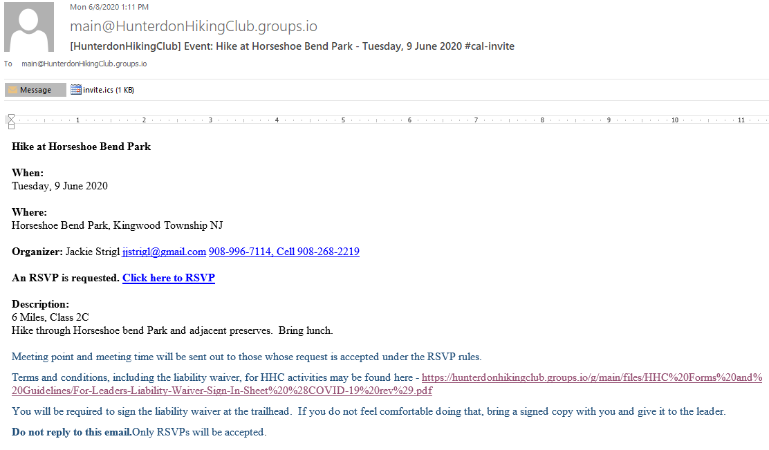
Email sent to Accepted Attendees with the Hike Information from the Note to Send Attendees field
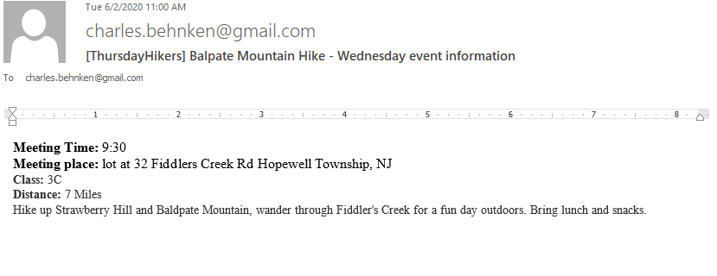

Example of Calendar RSVP page

